Lecturer’s name: N/A | Date: Day 4
Course: Math 6 | Unit: Operations with Positive Fractions and Decimals
Unit Duration: 10 | Lesson Duration: 2 days
TEKS: 6.3ER | Lesson Part #2
Topic: Dividing Decimals Day 1

Lesson objectives:
- I can write division problems three different ways.
- I can use the terms: dividend, divisor, and quotient correctly.
- I can explain why writing remainders in fraction form can be more efficient than writing them in decimal form.
- I can interpret remainders in terms of a problem situation.
- I can divide decimals

Essential Questions:
- How can I divide decimals using long division?
- How can I divide whole numbers and decimals using long division?
- In what other ways can the remainder be written besides just the “R”?
- Can a reminder be written as a fraction?

LYS Methodology
Be (Character/Values/Principles) - How does dividing values help me be more disciplined and dedicated?

Know (What resources are available to the student/ How can they use them) - Knowing and understanding the steps with division mathematically can help students understand the importance of resourcefulness, setting boundaries, and assertiveness

Do (Execute with Excellence) - Dividing values will help students be more driven while managing values and opportunities
Resources (Include Technology):
Instructional Input - Asynchronous
AS: Anticipatory Set (Introduction)
- Students practice long division with problems in which the dividend has a decimal. This will push the student to practice on problems they were working on the day before and reinforce learning with more practice

M: Modeling (I do)
- Introduce KP #1 show below
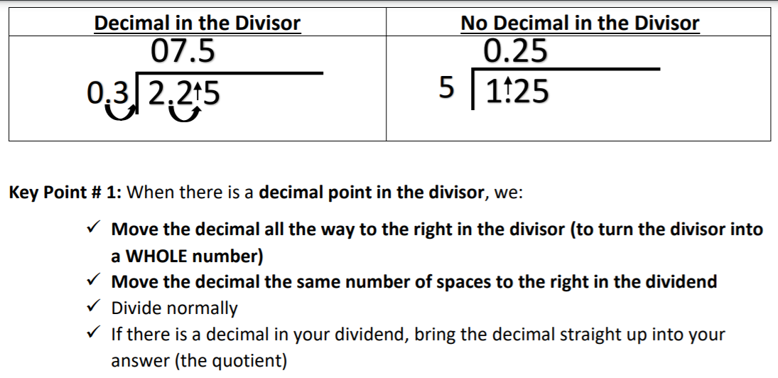
- Teacher models example 1
- Teacher GUIDES students through example 2 but pushes students to complete problem on their own
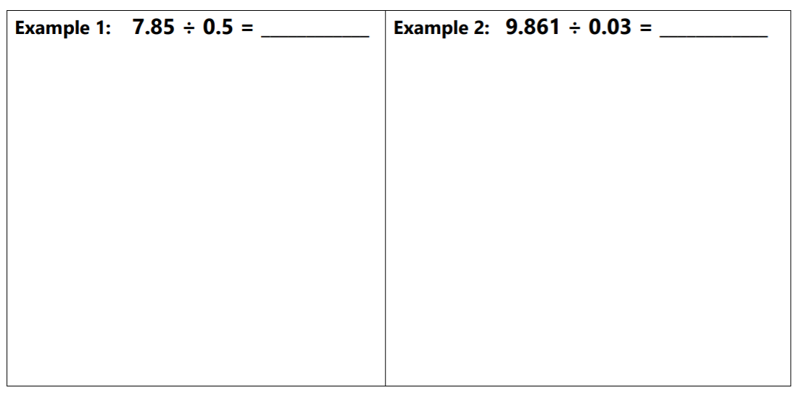

GP: Guided Practice (We do)
- On the practice, students are pushed to view division in different forms as a fraction, using the “house” and the division symbol
- As students are working through these problems, there is a CFS that they should follow
- Criteria For Success: When there is a decimal point in the divisor…
  - Move the decimal all the way to the right in the divisor (to turn the divisor into a WHOLE number)
  - Move the decimal the same number of spaces to the right in the dividend
  - Divide normally
  - If there is a decimal in your dividend, bring the decimal straight up into your answer (the quotient)

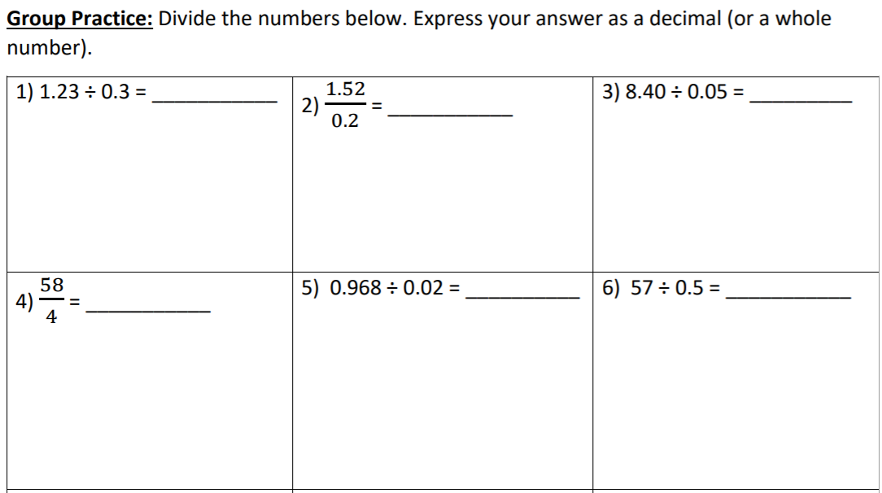

High-Level Rigor Questions
- Push students to complete high-rigor questions to ensure they understand the math with word problems such as these:
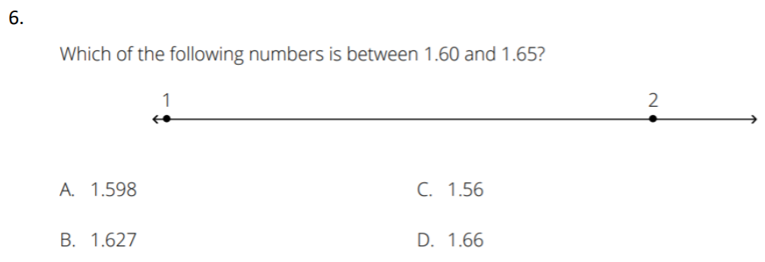
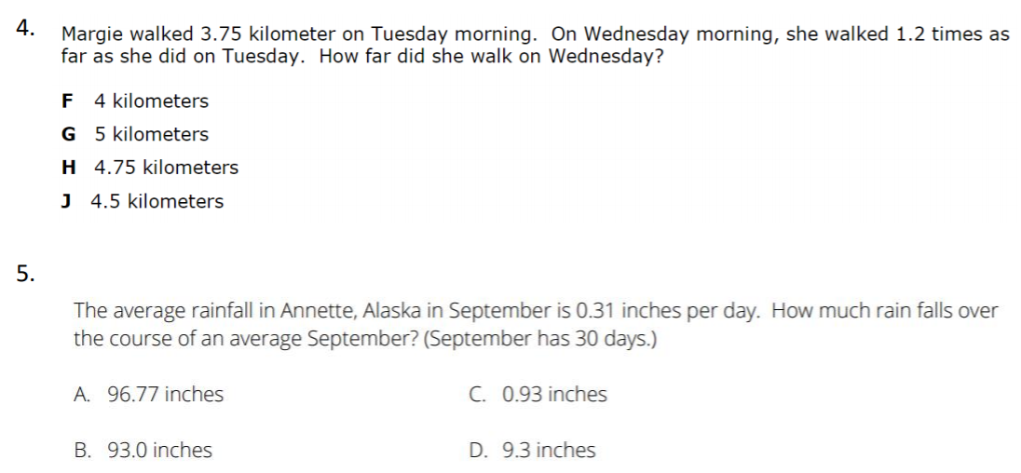

Instructional Input - Synchronous
AS: Anticipatory Set (Introduction)
- Students practice long division with problems in which the dividend has a decimal. This will push the student to practice on problems they were working on the day before and reinforce learning with more practice

M: Modeling (I do)
- Introduce KP #1 show below

- Teacher models example 1
- Teacher GUIDES students through example 2 but pushes students to complete problem on their own


GP: Guided Practice (We do)
- On the practice, students are pushed to view division in different forms as a fraction, using the “house” and the division symbol
- As students are working through these problems, there is a CFS that they should follow
- Criteria For Success: When there is a decimal point in the divisor…
  - Move the decimal all the way to the right in the divisor (to turn the divisor into a WHOLE number)
  - Move the decimal the same number of spaces to the right in the dividend
  - Divide normally
  - If there is a decimal in your dividend, bring the decimal straight up into your answer (the quotient)



High-Level Rigor Questions
- Push students to complete high-rigor questions to ensure they understand the math with word problems such as these:



Independent Practice/ Homework
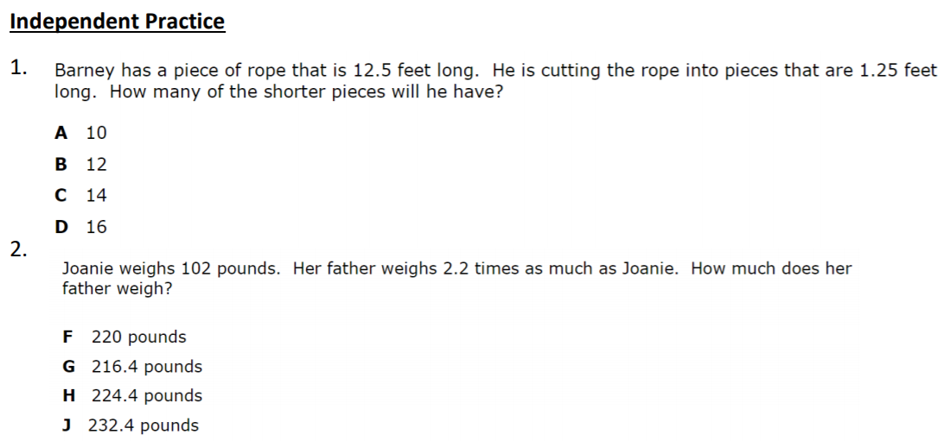
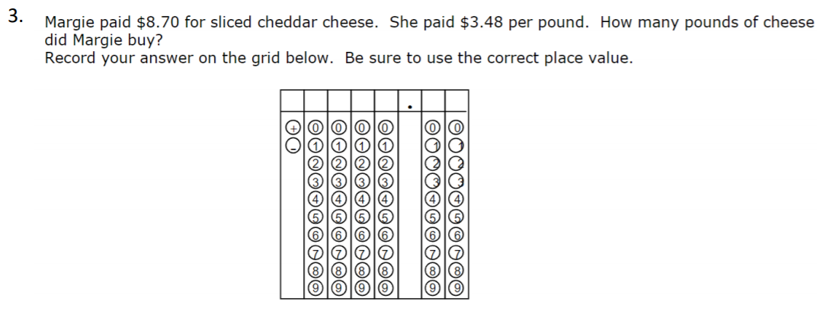

Additional Practice
- Combine practice from Day 1 and Day 2

Lesson Close

Discipline is the bridge between goals and accomplishment - Jim Rohn

We use decimals everyday while dealing with money, weight, length etc. Decimal numbers are used in situations where more precision is required than the whole numbers can provide. For example, when we calculate our weight on the weighing machine, we do not always find the weight equal to a whole number on the scale.

